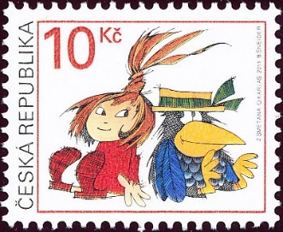
Napiš adresu:

_________________________________________
_________________________________________
_________________________________________
_________________________________________

Dopis pro kamaráda:
_________________________________________________________________________________________________________________________________________________________________________________________________________________________________________________________________
Obrázek:
____________________________________________________________________________________________

